These are minutes of the Board meeting held Thursday, January 12, 2023. The meeting was held via Zoom

Present at the meeting were the following:

Farrel Lewis [President] | Mike Schmidt [Board] | Dennis Kendrick [Board]
Roger McFarland, Board | Rick Patterson [Board] | Nate Ariotti, [Board]
Russ Ridges, [Board] | Clint Gailey [Roads Committee Chair
Mike Gailey [Secretary] | Roger Howell, Property Owner] | Absent were:
 | Ron James [Board] | Gary Nuffer, [Treasurer]

Welcome—Farrel welcomed the Board to the meeting. There were some difficulties for some in linking into the meeting a quorum was finally reached at 7:15 PM. An agenda had been prepared and sent to all Board members a week before the Board meeting.

Communication—Farrel asked Mike Gailey to report for the Communications Committee. The first matter of business was the approval of the minutes of the November 10, 2022, Board meeting. After some discussion Nate Ariotti made a motion to accept the minutes as prepared. A second was made by Dennis Kendrick. The vote was unanimous.

This meeting had been set aside after the November 10, 2022, meeting to establish penalties for breaches in compliance of the general membership to the governing documents of the Association. This discussion lasted for an hour. The following represents the determination of the Board for each infraction and was adopted by the Board by resolution that night by line item.

Reference | Description | Penalty
Bylaw 4.2.3 | Additional or Replacement Key | $50.00
Bylaw 4.2.4 | Loaning of keys | $500.00
Bylaw 4.2.5 | Failure to secure Association gates | $500.00
Bylaw 12.2.2 | Fees not paid by September 1st each year | $50.00
Bylaw 12.2.3.1 | Fees not paid for each year in default | $100.00
Bylaw 14.1.2 | Once a charge of nuisance has been established by the Board | Second offense: $250.00  Third offense: $500.00  Fourth offense: $1000.00
CCR 2.2.1.4 | Recreational off-road travel | $800.00 + mitigation for the effected landowner
CCR 2.2.1.5 | Failure to observe posted speed limits | $250.00
CCR 3.1 | Failure to meeting with the Development committee prior to any new development of property | The project shall be “red tagged” by the Development Committee.
CCR 4 | Nonapproved land use | $500.00
CCR 4.5 | Hunting without a permit or with a nonauthorized guest | $500.00 + loss of hunting privileges for 2 years. A second offense will result in a 5-year ban
CCR 4.6 | Recreational shooting | $500.00
CCR 4.6.1 | Infractions of the Quiet Time Hours | Second offense: $250.00  Third offense: $500.00  Fourth offense: $1000.00
CCR 4.8 | Using property for commercial gain | $2500.00
CCR 4.9 | Unauthorized animal keeping | $250.00

Farrel then asked Mike to explain the intent behind moving the Association’s records to Dropbox to allow access to the Board. Farrel has concerns that our directory and financial information is scattered on several computers. He would like it centralized for the benefit of future boards.

Mike explained that he maintains a Dropbox account. Dropbox is free to anyone wishing to store up to 2 gb of memory. Mike has created a folder in Dropbox entitled: HPME Online. He has given permission to Farrel to experiment with for the last month. Each committee of the Association has a folder there the houses critical information for that committee. After some discussion the Board authorized this move. Mike will be sending each Board member a link to that folder in Dropbox.

Finance—With the absence of Gary, Farrel reviewed the financial statement submitted by Gary.

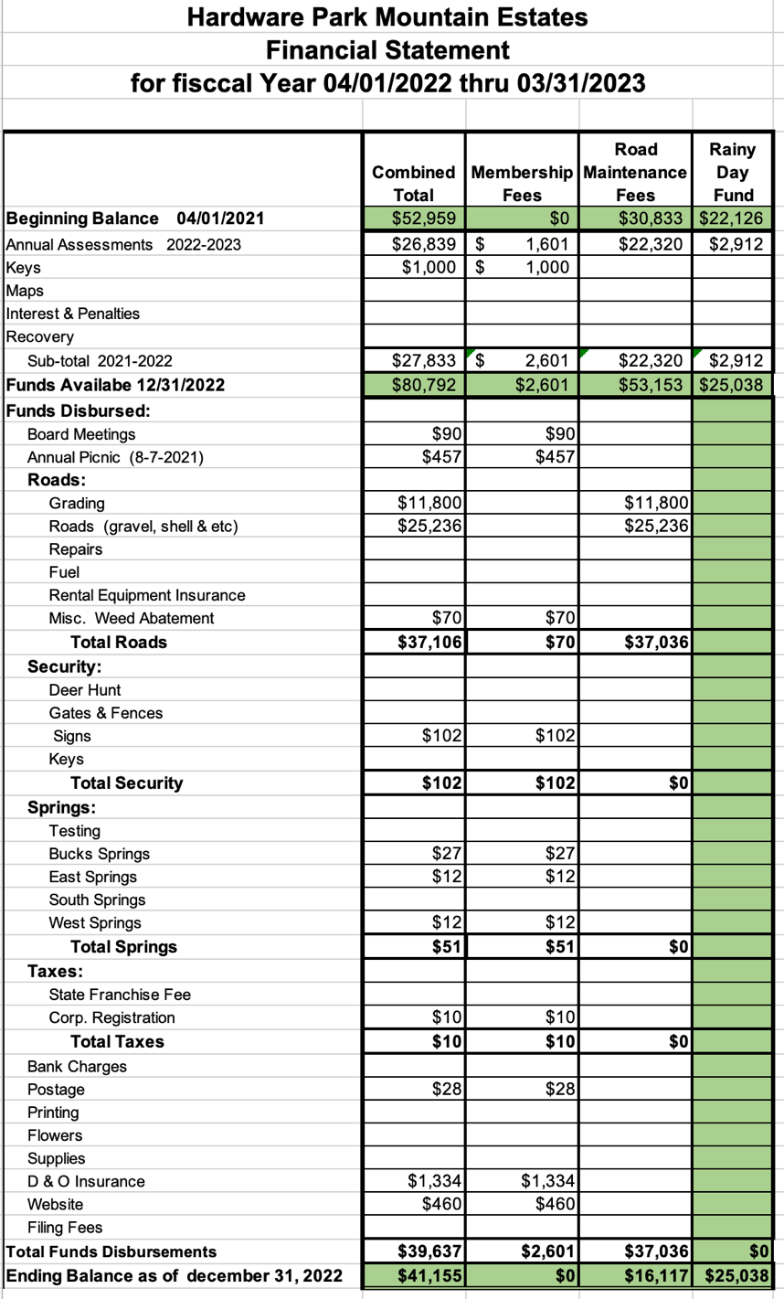
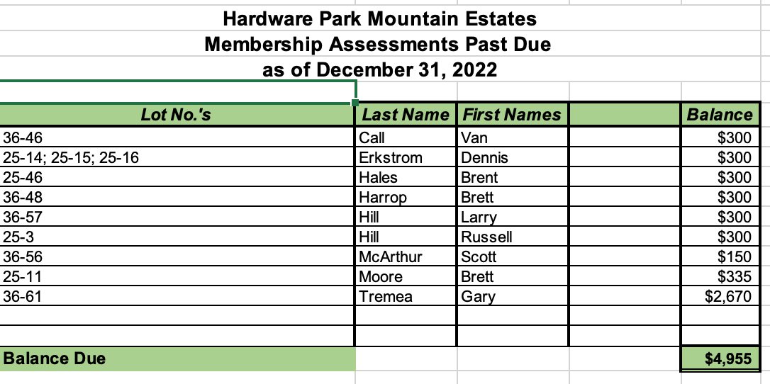

Farrel asked for a motion to accept the financial statement as prepared by Gary. Roger McFarland made a motion to accept. Rick made a second. The vote was unanimous.

Security and Fire—Farrel asked Dennis if he had anything that he’d like to bring before the Board other than the two items on the agenda. Dennis had none.

At the September and November board meetings discussions were held concerning a complaint made by other landowners of the actions of Casey Schradley’s guests on August 20, 2022. Casey was sent a certified notice requesting his presence at the November 10, 2022, hearing. Mr. Shradley did not come to this fact-finding hearing. It was the determination of the Board that penalties needed to be established by the Board for infractions of the Bylaws and CCRs. This was done earlier in the meeting. Casey was invited to attend this meeting, but the invite was returned “refused”. Mike has spoken with Casey by phone and advised him of the meeting. Casey disclosed that those guests were his sons. Mike was told that he would not attend. Mike was assigned to draft a notice to Casey listing the penalties for the infractions he refused to defend.

The second item discussed under this heading was the infraction of leaving an Association gate unsecure. This charge has been levied against a new landowner, Rusty Tubbs. This infraction was witnessed by another landowner and reported to the Board. Mike was instructed to write a letter to Mr. Tubbs as warning and a first offense document.

Emergency Preparedness—Mike Schmidt reported that there was some movement in the issue with the lockbox at the Ant Flat gate. Mike met with Sheriff’s office at the gate and the County demonstrated that the key given to them will not open the box because of damage done to the box by a shooter. The Association will have to provide another box. Farrel asked Mike to determine the cost for that replacement box and place it into this year’s budget.

Russ Ridges reported that he witnessed the box being shot and identified on the Hill boys as the shooter. This was done three years ago. The boy was drunk and with a firearm, Russ didn’t feel comfortable confronting him.

Activities—With Ron not present, it was simply announced that the general meeting of members will be held again in Syracuse on March 16, 2023. The Board also determined that the meeting will not be Zoom broadcast. Any landowner can send a proxy to the meeting where an election will occur.

Development—Roger McFarland reviewed a letter he had drafted to Lance Gardner concerning future development on his property. Mike Gailey was assigned to produce the letter that would go out under Roger’s signature. The letter advises Mr. Gardner that any future development must be run through the Development Committee.

Roads and Maintenance—Russ feels like the current road maintenance program is not working. Many are given credit without producing. He suggested that work parties be assembled on the first Saturday of the months of June, July, August, and September to work on specific areas needing attention. Work credit will be given to those who work 8 hours as an individual or 10 hours for a family counting each family member. These work parties would be supervised by a member of the Roads Committee, and they will provide a timecard for those seeking work credit. Clint Gailey, Chair, was also present and felt good about the new proposal. A motion was made by Russ to approve this action. Rick placed a second. The vote was unanimous. Clint and Russ will get together before the next Board meeting and be prepared to present their effort to the Board next time.

Hunting—Rick informed the Board that he is currently dialoging with the DWR concerning the poaching of moose, elk, and deer. He is trying to get the DWR to allow the Association to also levy a fine for poaching when documented. The DWR is certain that the poachers in the last two incidents involving moose are members or guest of the Association. Rick said he has been assigned to work with an attorney retained by the DWR. His name is Charles Lyons. Rick will keep the Board appraised of this work.

Water and Health—Nate advised the Board that he and Stevan Wilson are working to update the Water Site Plan. They feel they would like to test each spring annually. Russ made a motion to approve. Nate seconded that motion. The vote was unanimous.

Farrel asked Nate if he’d been in contact with Dick Forsgren from County Noxious Weed Control. Nate said that he had not. According to Farrel, the County will no long spray Association roadways for free. They will be charging $50.00/acre. Those with noxious weeds on their lots will be charged at the same rate. Farrel asked Nate if he’d investigate this for the Board. Nate accepted that assignment.

Miscellaneous—Farrel thanked Roger Howell for his attendance. He asked those up for re-election if they would be willing to put their name into the hat again. All agreed. Mike was instructed to place a notice on the website asking for others to place their name in nomination.

Farrel called for a motion of adjournment: Dennis made that motion, seconded by Russ. The meeting was adjourned at 8:55 PM.

Ron’s wife had an emergency, and he was out of the country.
It should also be noted that Rick has lost a daughter to ALS since the Board last met.

